**Experiment No. 6**

**Aim:** To implement programs based on Inheritance and Polymorphism.

**Questions:**

1. Write a program to implement the following. Create a base class called Person consisting of name and code. Create 2 child classes a) Account with member_pay and b)Adnmin with experience and inherit the base class. Create a class Employee with name, code, experience and pay by inheriting the above classes.

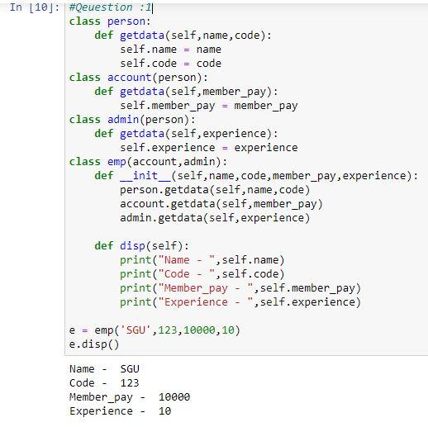

1. Create a class called Staff with code and name. Create classes Teacher (subject, publication), Typist(speed), Officer(grade). Using the typist class as base class, create 2 classes Regular(salary) and Casual (daily wages). Implement a menu driven program for the same.

class staff:

def staffdata(self,code,name):

self.code = code

self.name = name

def disp(self):

print("Code - ",self.code)

print("Name - ",self.name)

class teacher(staff):

def teacherdata(self,subject,publications):

self.subject = subject

self.publications = publications

def disp(self):

print("Subject - ",self.subject)

print("Publication - ",self.publications)

class typist(staff):

def typistdata(self,speed):

self.speed = speed

def disp(self):

print("Speed - ",self.speed)

class officer(staff):

def officerdata(self,grade):

self.grade = grade

def disp(self):

print("Grade - ",self.grade)

class regular(typist):

def regulardata(self,salary):

self.salary = salary

def disp(self):

print("Salary - ",self.salary)

class casual(typist):

def casualdata(self,daily_wages):

self.daily_wages = daily_wages

def disp(self):

print("Daily wages : ",self.daily_wages)

ch = 0

while ch != 5:

print("1.Teacher")

print("2.Officer")

print("3.Regular Typist")

print("4.Casual Typist")

print("5.Exit")

ch = int(input("Enter your choice - "))

if ch == 1:

obj = teacher()

code = input("Enter code : ")

name = input("Enter name : ")

obj.staffdata(code,name)

obj.teacherdata("SPP","SGU")

obj.disp()

if ch == 2:

obj = officer()

code = input("Enter code : ")

name = input("Enter name : ")

obj.staffdata(code,name)

obj.officerdata("A Grade")

obj.disp()

if ch == 3:

obj = regular()

code = input("Enter code : ")

name = input("Enter name : ")

obj.staffdata(code,name)

obj.regulardata(100000)

obj.disp()

if ch == 4:

obj = casual()

code = input("Enter code : ")

name = input("Enter name : ")

obj.staffdata(code,name)

obj.casualdata(50000)

obj.disp()

else :

print(" --- Successfully Exit --- ")

**Output :**

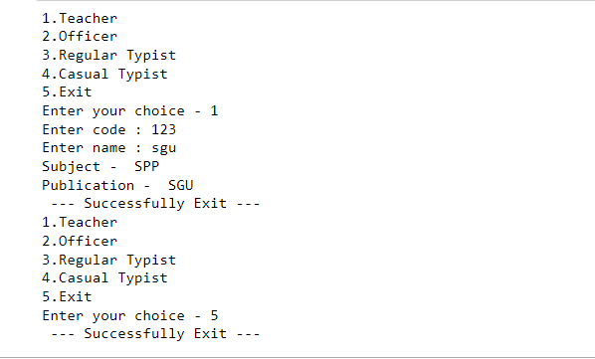

1. Write a program in Python to demonstrate operator overloading.

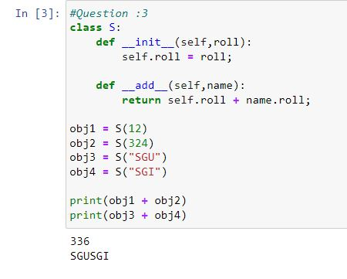

1. Write a program in Python to demonstrate method overriding

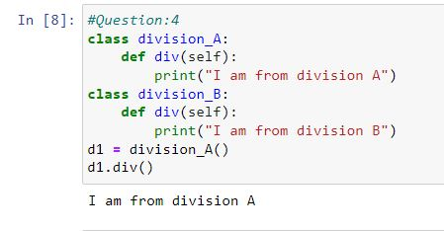

1. Write a program in Python to demonstrate multiple inheritance.

